
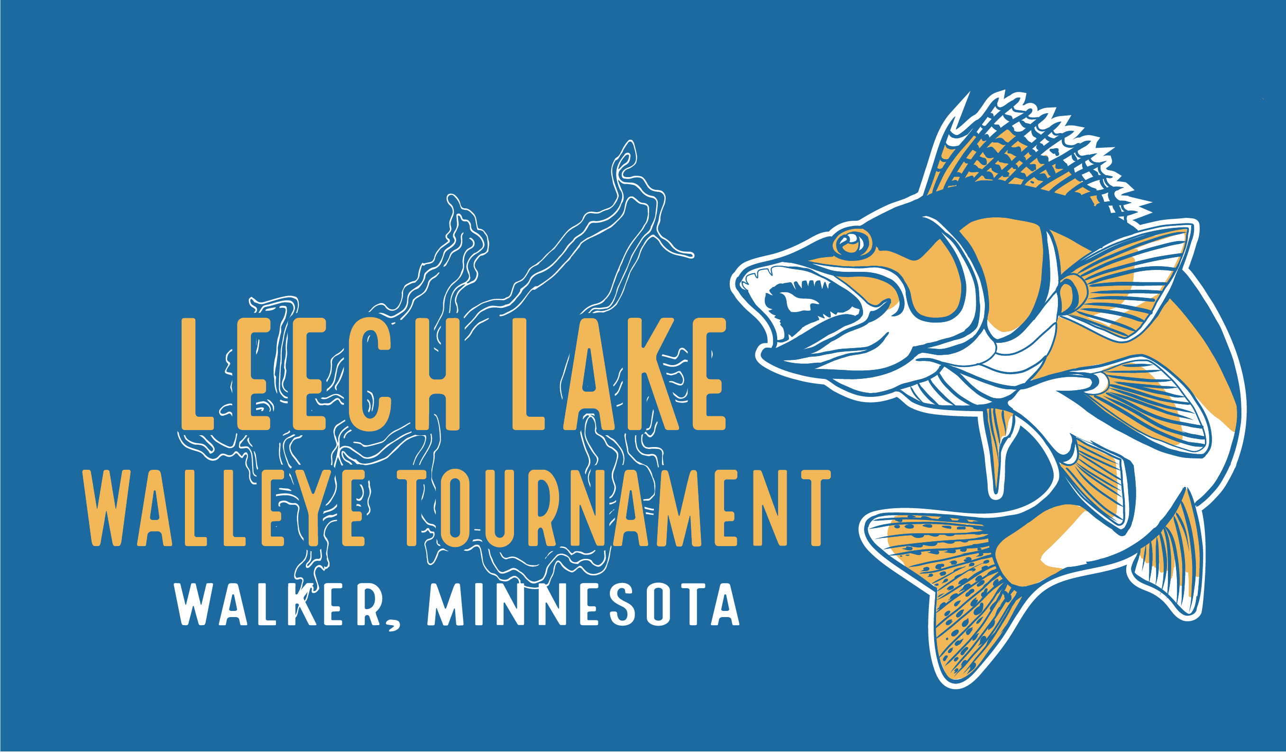

RELEASE OF LIABILITY LEECH LAKE WALLEYE TOURNAMENT

In consideration of being allowed to participate in the Leech Lake Walleye Tournament, we ___________________ & ___________________the undersigned, being of at least 18 years of age, acknowledge, appreciate, and agree that:
1. The risk of injury from the activities involved in this program is significant, including the potential for permanent paralysis and death, and while skills, equipment, and personal discipline may reduce this risk, the risk of serious injury does exist; and,
2. We KNOWINGLY AND FREELY ASSUME ALL SUCH RISKS, both known and unknown, EVEN IF ARISING FROM THE NEGLIGENCE OF THE RELEASEES or others, and assume full responsibility for my participation; and,
3. We, for myself and on behalf of my heirs, assigns, personal representatives and next of kin, HEREBY RELEASE, INDEMNIFY, AND HOLD HARMLESS THE Leech Lake Area Chamber of Commerce, their officers, officials, agents and/or employees, other participants, sponsoring agencies, sponsors, advertisers, and, if applicable, owners and lessors of premises used for the activity ("Releasees"), WITH RESPECT TO ANY AND ALL INJURY, DISABILITY, DEATH, or loss or damage to person or property, WHETHER ARISING FROM THE NEGLIGENCE OF THE RELEASEES OR OTHERWISE, to the fullest extent permitted by law.
We HAVE READ THIS RELEASE OF LIABILITY AND ASSUMPTION OF RISK AGREEMENT, FULLY UNDERSTAND ITS TERMS, UNDERSTAND THAT I HAVE GIVEN UP SUBSTANTIAL RIGHTS BY SIGNING IT, AND SIGN IT FREELY AND VOLUNTARILY WITHOUT ANY INDUCEMENT.

x________________________________ Age: ____ Date Signed: ________________
PARTICIPANT'S SIGNATURE

x________________________________ Age: ____ Date Signed: ________________
PARTICIPANT'S SIGNATURE/GUARDIAN SIGNATURE

